MINUTE for MISSION Sept 25 CLIMATE RESILIENCY 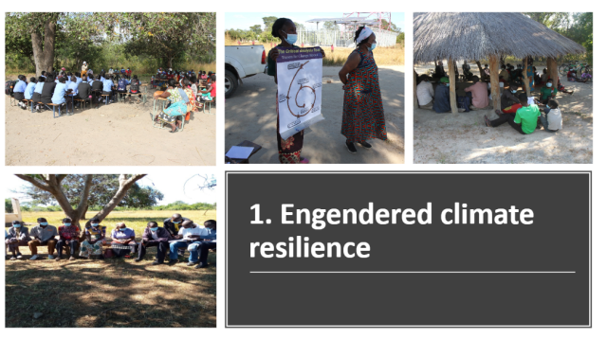
Slide prepared by Women for Change shows their community-based work to develop climate resiliency.

In areas where historically there has been little rain, now there are floods, and where there were floods, now there are droughts. That’s how Shadrick Chembe, the Monitoring and Evaluation Manager at Women for Change—an organization in Zambia that strives to improve conditions in rural communities by empowering women and girls—describes the changing climate in Zambia. Women bear the brunt.

“In Zambia, women are still responsible for collecting firewood and charcoal and making food. Now, because of climate change, they have to walk a longer distance to gather firewood. Charcoal is harder to get. That means it’s harder to make food. At the same time, women aren’t involved in the decision-making processes that impact this work,” explains Chembe.
Women for Change was established in 1992, and its long-standing partnership with the United Church stretches back to1995. From the beginning, mobilizing communities to share ideas and best practices has been key to the work. Since its inception, 1,500 community groups have been established, with 25-40 people in each group and representatives from each forming associations. The groups discuss a variety of justice-related topics. Building climate resiliency by preparing for, recovering from, and adapting to drastically changing weather patterns is a priority.
Weather extremes due to climate change coupled with companies promoting seeds that only produce a single crop increasingly put people at risk.
“The majority of farmers are poor. They can’t buy seeds, but companies have created seeds that force farmers to have to purchase them each year,” says Chembe. “Groups discuss how they can save and share seeds, what they can plant with longer or shorter rains, and if there are traditional methods that can increase food production,” he says, adding, “We are grateful for the United Church’s support. The church has really been there for many years, helping us build awareness and resiliency. It’s been a real partnership.”

Your gifts through Mission & Service support long-term, life-changing work through committed partners like Women for Change. Thank you.

